| **Date** | **31 OCTOBER 2025** |
| --- | --- |
| **Team ID** | **NM2025TMID00034** |
| **Project Name** | **Laptop Request Catalog Item** |
| **Maximum Marks** | **4 Marks** |

### Project Design Phase-II

## Data Flow Diagram & User Stories

### Data Flow Diagrams:

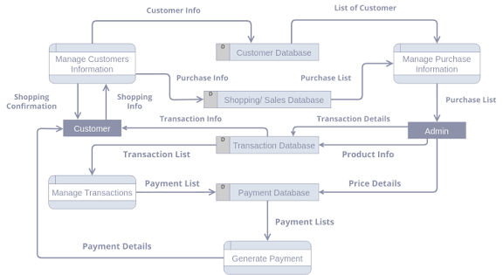

A **Data Flow Diagram (DFD)** for the Laptop Request Catalog Item project visually represents the information flow from the user's initial request to the final provisioning of the asset. [cite_start]The DFD highlights how data is processed, what systems interact, and where data is stored.

In this project, the DFD illustrates the interaction between the **Employee**, the **Service Catalog** system, the **Manager**, the **Fulfillment** process, and the **IT Asset Database (CMDB)**. It ensures that data, such as request details, approval status, and asset information, is consistently passed through the system to maintain accuracy and accountability.

**DFD Flow Description:**

1. The **Employee** (External Entity) enters **Request Details** into the **Service Catalog Form** (System) and submits the request.
2. • The **Service Catalog** creates a **Request Item (RITM)** and passes an **Approval Request** (Data Flow) to the **Manager** (External Entity).
3. • The **Manager** sends an **Approval Status** (Data Flow) back to the **RITM** in the **Service Catalog** (System).
4. • If approved, the **Service Catalog** passes a **Fulfillment Task** (Data Flow) to the **IT Hardware Fulfillment** (Process).
5. • The **IT Hardware Fulfillment** process retrieves **Asset Information** from the **CMDB** (Data Store) and sends the **Product** (Data Flow) to the **Employee**.

Upon completion, the **IT Hardware Fulfillment** process sends an **Asset Update Record** (Data Flow) back to the **CMDB** (Data Store) to finalize asset tracking.

### User Stories:

[cite_start]User stories define the functionality needed from the system in simple, goal-focused language, ensuring the final product meets the needs of all stakeholders.

| **User Type** | **Functional Requirement (Epic)** | **User Story Number** | **User Story / Task** | **Acceptance criteria** | **Priority** | **Release** |
| --- | --- | --- | --- | --- | --- | --- |
| **Employee (End User)** | Catalog Item Submission | USN-1 | As an **employee**, I want to select my desired laptop model and see the specifications and pricing on the request form. | The form must clearly display model names (e.g., 'Standard' or 'Developer'), specifications, and cost. | High | Sprint-1 |
| **Manager** | Workflow Approval | USN-2 | As a **manager**, I want to receive an approval request via email for my direct report's laptop request with a single-click approve/reject link. | The approval record must contain all request details (user, model, cost); the approval action must update the request status correctly. | High | Sprint-2 |
| **IT Hardware Agent** | Request Fulfillment | USN-3 | As an **IT Hardware Agent**, I want a task created in my fulfillment queue that lists the laptop model, user contact information, and delivery location. | The task must be auto-assigned to the correct fulfillment group and contain all details needed for provisioning. | High | Sprint-2 |
| **System (Automated)** | Asset Management | USN-4 | As the **system**, I must update the CMDB to create or update the asset record with the correct Asset Tag and link it to the requester upon request fulfillment. | A new Configuration Item (CI) must be created/updated with the correct Model, Asset Tag, and Assigned To fields linked to the requester. | High | Sprint-3 |
| **Employee (End User)** | Notification & Tracking | USN-5 | As an **employee**, I want to receive an email notification when my laptop request is submitted, approved, and when the asset is ready for pickup/delivery. | Email notifications must be automatically triggered at key stages and contain the request link and current status. | Medium | Sprint-3 |
| **IT Asset Manager** | Reporting | USN-6 | As an **IT Asset Manager**, I want a dashboard that displays the total count and cost of all laptop requests submitted in the last 30 days. | A real-time report must be available, filterable by model, department, and time period, and show total cost. | Medium | Sprint-3 |